Devops Portfolio

# MICHAEL PLASOM-SCOTT

For DWP Digital and Makers Academy

## Contents

##### About

Intro To Me

The Team

My Role

Tech Stack

##### Portfolio

Ticket Name

Ticket Description

Ticket Process

Knowledge

Skill

Behaviour

##### DUTIES

Knowledge

Skill

Behaviour

## About

##### Intro To Me

I'm Michael Plasom-Scott. I studied as a Graphic Designer, worked as a teaching assistant and technician in a school, and I'm now re-training as a DevOps Engineer. I come from a creative and collaborative background, that although does not scream DevOps has been vital to my development in the role.

This course is a brilliant opportunity to have a glimpse into a fascinating industry, completely unlike anything I've tackled before. Every day is a new challenge, and I haven't stopped learning since day one.

##### The Team

My team is an agile team led by Tom Farrow. Along with my Line Manager, Shazad Azam, they have been extremely helpful in helping me get to grips with the day-to-day life and work ethic of a DevOps engineer. The team has daily morning standups in which we talk about what was achieved yesterday, what we plan to achieve in the coming day, and any blockers that might stand in our way. It’s also an opportunity to ask any questions or for advice. Tickets are assigned at the start of a sprint, and completed as quickly as possible, with as much communication as possible. I spent a lot of my time at the start of my placement shadowing Luis Castromil, another DevOps engineer, who moved on to giving me tickets to try myself.

##### My Role

My role is that of Apprentice DevOps Engineer in the Digital Shared Channels Experience (DSCE) at DWP. I’m in the Notifications team within this, however some projects I do affect multiple teams within the DSCE Directorate.

##### Tech Stack

AWS

S3

Lambda

Cloudwatch

DynamoDB

Terraform

Ansible

Prometheus

Grafana

Gitlab

## Portfolio

Project #1

##### Ticket Name

NSE-2264

##### Ticket Description

Create an S3 Bucket with the local name Data Migration Changes. S3 access then provided to Data Specialist who will pull the files Users.CSV and Org_Node.CSV that will be uploaded to SharePoint. Users.CSV needs to be encrypted. Files to be exported to S3 location Wed/Fri by 8am.

This ticket was assigned to me as a way of getting me used to an agile workflow and working alongside developers to roll out some changes.

##### Ticket process

Meeting with Luis  
The process started with a call with Luis where he outlined what would need to be done, and then updated the ticket with a bullet pointed list of everything. He also said one of the first things to tackle would be the creation of a GitLab CI/CD pipeline. Tyler and I said we’d split up the basic work, he’d focus on writing the terraform of the Lambda and I’d focus on the pipeline. S3

Creating the pipeline  
I spent a while on the initial stage of the pipeline. It was my first time creating a GitLab CI/CD pipeline at DWP, so I was unaware of the protocol used. I looked at other examples of pipelines from different repositories that the team had worked on and spent a while trying to decipher how they worked. Working on my own branch in the repository, I pushed up a few very simple versions of what I understood, to try and see if I could get something minimal off the ground and build it up. I couldn’t understand why these were failing so I set up a call with Luis and we workshopped around the setup of a pipeline. After that it became a lot clearer and I eventually pushed up a merge request with a pipeline that worked as it should, with the correct steps in it.   
K1, K2, K19

Code review by Luis  
Once the pipeline was working as expected, Luis took the time to review the code that Tyler and I had in the repo. This was an incredibly helpful step, and one of the key parts of a smooth and agile DevOps environment. Often it was small things like not following the correct naming conventions (fig. 1), however Luis would often take the time to highlight important DevOps principles, as a learning opportunity for me (fig. 2). Graphical user interface, text, application, email

Figure 1 - Code Review comment from Luis

Figure 2 - Code Review comment highlighting DevOps Principle

K23

Fixing Changes  
Following the code review I worked by myself to make sure the suitable changes were applied. This involved a lot of simple changes to variables within the file, which were simple. However, there were some elements that I was unfamiliar with, particularly the scheduling of Lambda functions, as was required by the ticket - Files to be exported to S3 location Wed/Fri by 8am - so I researched around ways to do this and looked in some other repos from the team to find examples of cron triggers. I settled on setting up the cron expression (fig. 3), so the file was exported on Wednesday and Friday at 7:30 and ran this by one of the [Business Analysts/Architects] to make sure that was a suitable time.

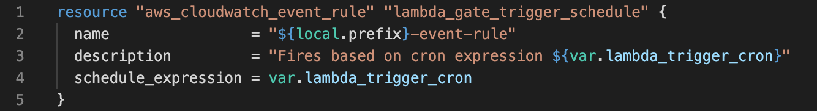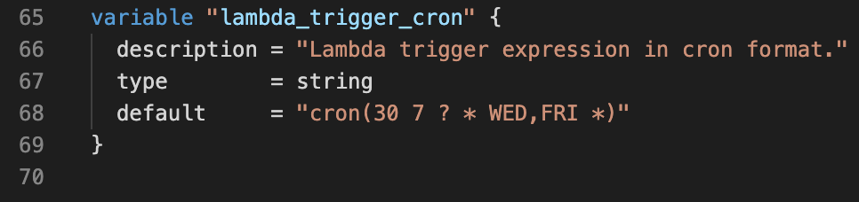

Figure 3 - Cron Trigger

K7, S15

Debugging with Developers  
Once the setup was all complete (in theory) from the DevOps side, a chat was created with me, Luis, Daniel, and Ritesh. Daniel and Ritesh were the developers adding some code in, using the pipeline I’d created. At this point some of the steps in the CI/CD pipeline started to fail – mainly catching errors in the code and doing what the pipeline is supposed to do in part, i.e. catch errors before going to deployment. However, one of the times it failed was due to an error in the Terraform code – the handler path in the Lambda config had been copied across from another repository and was incorrect, so I updated the code and pushed again. Another error that slipped through the net was that the Lambda wasn’t given enough time to connect to the database, having 3 seconds as a default. This gave the Devs an error message, which they fed back to me, and I fixed in the Terraform code (fig. 4). Graphical user interface, text

Figure 4 – Devs highlighting error

S8, B3

Deploying to DSE-1  
Having fixed the bugs and got the pipeline running smoothly, we took finished for the weekend. On Monday Luis started a call with me and demonstrated to me the way that we deploy code into the DSE-1 (Develop Support) environment.  
S5

Business Impact  
The changes we made created an AWS Lambda that retrieves data from a bucket, encrypts it using a public key, and places it in another bucket. A user can then access that bucket through Sharepoint, download the data, and decrypt it using a private key. This automates a process that was previously done manually and makes it a lot more secure with the use of encryption. The pipeline created means that developers can constantly make incremental changes to this code safely.

##### Knowledge

K1 - Continuous Integration - the benefits of frequent merging of code, the creation of build artefacts and ensuring all tests pass, with automation throughout - including common tooling.

K2 - The principles of distributed Source Control, including how to exploit the features of the tool, such as branching.

K7 - General purpose programming and infrastructure-as-code.

K19 - Different methods of communication and choosing the appropriate one - e.g. face-to-face (synchronous, high bandwidth), instant messaging, email (asynchronous, low bandwidth), visualisations vs. words.

K23 - The importance of continual improvement within a blameless culture.

##### Skill

S3 - Translate user needs into deliverable tasks, writing clear, concise and unambiguous user stories that the whole team can understand.

S5 - Deploy immutable infrastructure

S8 – Work in agile, multi-disciplinary delivery teams, taking a flexible, collaborative and pragmatic approach to delivering tasks.

S15 - Release automation and orchestration as part of a Continuous Integration workflow and Continuous Delivery pipeline, automating the delivery of code from source control to the end users.

##### Behaviour

B3 - Displays a commitment to the mantra 'You build it, you run it', taking ownership of deployed code and being accountable for its continual improvement, learning from experience and taking collective responsibility when things fail.

Project #2

##### Ticket Name

NSE-

##### Ticket Description

The project is a large job that will affect multiple teams within the SCE Directorate. Within the directorate there are multiple silos of technical stacks, for example Notifications, and ECMP, etc. with multiple teams working within them. The task would be to create an accessible single view location across the entire directorate. This location would have dashboards covering various aspects and display monitoring for all the projects, with all issues highlighted. These issues would then be triaged effectively by the respective team. Effectively this would mean that any issue can be compared across all the projects and give visibility to whether it was a lone issue or affecting multiple projects. It would be a huge update and improvement on a system already in place that does not house the monitoring in one place.

##### Ticket Process

Workshop with Tom Farrow

Tyler and I went into the Manchester office for a workshop with the DevOps lead for our team, Tom. It being the first time I’d been in the building to work, Tom led us through the basic health and safety procedures, including fire evacuation. We then went through the requirements for the project and came up with an idea of the architecture required to get it to work. The basic structure would be a User accessing Grafana via a load balancer to query Prometheus and Alert Manager. In the workshop we worked on a diagram, and Tyler digitised the diagram to this (fig. 5) that displays our initial attempt at the architecture required to continue with the project.

Figure 5 - Initial Diagram after Workshop

Architecture Call with Matthew Mann

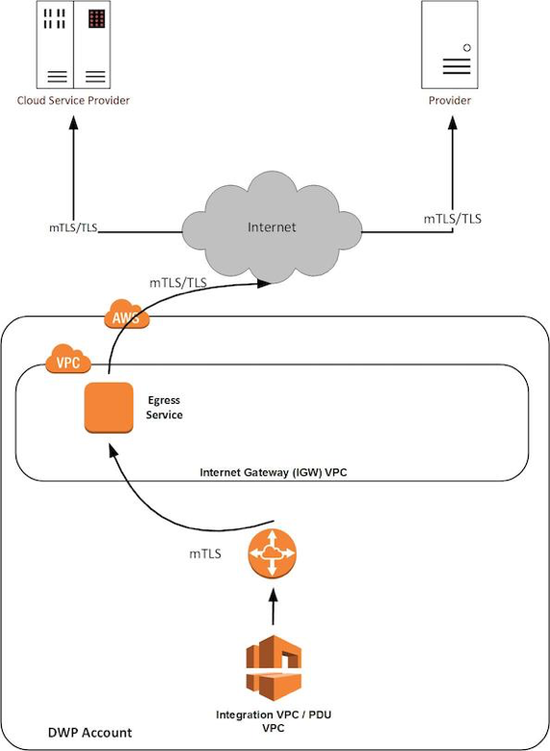Following our workshop with Tom, we were told we had to run the architecture design past Matthew Mann, the architect for the Notifications project. Matthew accessed our proposal for compatibility with DWP data protection and highlighted the importance of keeping citizen information secure tom comply with GDPR. He advised us to use a different pattern (fig. 6) instead of the transit gateway that we pitched, and he linked us to the correct pattern.

Figure 6 - Internet Egress Pattern provided by Architect

This project is ongoing

##### Knowledge

##### Skill

##### Behaviour

## KSBs

##### Knowledge

1. Continuous Integration - the benefits of frequent merging of code, the creation of build artefacts and ensuring all tests pass, with automation throughout - including common tooling.
2. The principles of distributed Source Control, including how to exploit the features of the tool, such as branching.
3. How to use data ethically and the implications for wider society, with respect to the use of data, automation and artificial intelligence within the context of relevant data protection policy and legislation.
4. The business value of DevOps in terms of Time, Cost, Quality, with an emphasis on building in internal Quality throughout the lifetime of the product.
5. A range of modern security tools and techniques - e.g., threat modelling, vulnerability scanning and dependency checking, with a general awareness of penetration testing - in order to deal with threats and attack vectors within code and across the cyber domain.
6. A range of problem-solving techniques appropriate to the task at hand, such as affinity mapping, impact maps, plan-do-check-act/Deming.
7. General purpose programming and infrastructure-as-code.
8. Immutable infrastructure and how it enables continuous refreshing of software, namely the updating of the operating system, container and security patching.
9. Different organisational cultures, the development frameworks utilised and how they can both complement each other and introduce constraints on delivery.
10. How the user experience sits at the heart of modern development practices in terms of strategies to understand diverse user needs, accessibility and how to drive adoption.
11. Monitoring and alerting technologies and an awareness of the insights that can be derived from the infrastructure and applications - collecting logs and metrics, configuring alerting thresholds, firing alerts and visualising data.
12. The persistence/data layer, including which database/storage technologies are appropriate to each platform type and application when considering non-functional and functional needs, e.g., monolith, microservice, read heavy, write heavy, recovery plans.
13. Automation techniques, such as scripting and use of APIs.
14. Test Driven Development and the Test Pyramid. How the practice is underpinned by unit testing, the importance of automation, appropriate use of test doubles and mocking strategies, reducing a reliance on end-to-end testing.
15. The principles and application of Continuous Integration, Continuous Delivery and Continuous Deployment, including the differences between them.
16. How best to secure data, e.g., encryption in transit, encryption at rest and access control lists (ACL).
17. What an API is, how to find them and interpret the accompanying documentation.
18. Roles within a multidisciplinary team and the interfaces with other areas of an organisation.
19. Different methods of communication and choosing the appropriate one - e.g., face-to-face (synchronous, high bandwidth), instant messaging, email (asynchronous, low bandwidth), visualisations vs. words.
20. Pair/mob programming techniques and when to use each technique.
21. Architecture principles, common patterns and common strategies for translating user needs into both cloud infrastructure and application code.
22. How their occupation fits into the wider digital landscape and any current or future regulatory requirements.
23. The importance of continual improvement within a blameless culture.
24. The difference between Software-as-a-Service (SaaS) v bespoke v enterprise tooling and how to make an informed choice that suits each use case.
25. Maintain an awareness of cloud certification requirements.

##### Skill

1. Communicate credibly with technical and non-technical people at all levels, using a range of methods; e.g. ‘Show and Tell’ and ‘Demonstrations’.
2. Work within different organisational cultures with both internal and external parties
3. Translate user needs into deliverable tasks, writing clear, concise and unambiguous user stories that the whole team can understand.
4. Initiate and facilitate knowledge sharing and technical collaboration
5. Deploy immutable infrastructure
6. Install, manage and troubleshoot monitoring tools
7. Navigate and troubleshoot stateful distributed systems, in order to locate issues across the end-to-end service.
8. Work in agile, multi-disciplinary delivery teams, taking a flexible, collaborative and pragmatic approach to delivering tasks.
9. Application of a range of cloud security tools and techniques - e.g. threat modelling, vulnerability scanning, dependency checking, reducing attack surface area - incorporating these tools and techniques into the automated pipeline wherever possible.
10. Assess identified and potential security threats and take appropriate action based on likelihood v impact.
11. Employ a systematic approach to solving problems, using logic and hypotheses / experimentation to identify the source of issues.
12. Automate tasks where it introduces improvements to the efficiency of business processes and reduces waste, considering the effort and cost of automation.
13. Engage in productive pair/mob programming.
14. Write tests and follow Test Driven Development discipline in various different contexts.
15. Release automation and orchestration as part of a Continuous Integration workflow and Continuous Delivery pipeline, automating the delivery of code from source control to the end users.
16. Invest in continuous learning, both your own development and others, ensuring learning activities dovetail with changing job requirements. Keep up with cutting edge.
17. Code in a general purpose programming language.
18. Specify cloud infrastructure in an infrastructure-as-code domain-specific language.
19. Interpret logs and metrics data within the appropriate context to identify issues and make informed decisions.
20. Writing code in such a way that makes merging easier and facilitates branching by abstraction - i.e. feature toggling.
21. Application of lightweight modelling techniques, such as whiteboarding, in order to gain consensus as a team on evolving architecture.
22. Incremental refactoring by applying small behaviour-preserving code changes to evolve the architecture.

##### Behaviour

1. Exhibits enthusiasm, openness and an aptitude for working as part of a collaborative community; e.g. sharing best practice, pairing with team members, learning from others and engaging in peer review practices.
2. Invests time and effort in their own development, recognising that technology evolves at a rapid rate.
3. Displays a commitment to the mantra 'You build it, you run it', taking ownership of deployed code and being accountable for its continual improvement, learning from experience and taking collective responsibility when things fail.
4. Is inclusive, professional and maintains a blameless culture.